Note IP address first threee group represent the IP of network(192.168.2) and only last 0 changes to represent end hosts in network. ‘/24’ is used to tell what part of the address represents network,and what part represents end hosts(PCs).’/24’ means that first three group of numbers represent network and forth is used to represent end host.Router needs IP address for each network it is connected to.S o lets give R1’s G0/0 interface an IP address of 192.168.1.254,and it’s G0/1 interface an IP address of 192.168.2.254.If PC1 sends broadcast frame,the SW1 receives it and forwards it to PC2 and R1,and this time the broadcast is limited to local network it doesn’t cross the router and go to to SW2,PC3 and PC4.IP or Internet Protocol is the primary Layer 3 protocol in use today and version 4 is the version in use in most networks.Two of fields of IP are ‘Source IP address’ and ‘Destination IP address’ each of them 4 bytes(32bits) in length.
Lets look at this IPv4 address 192.168.1.254 each of 4 groups of number (192,168,1.254) are 8 bits because IPv4 address itself is 32 bits(So it is divided by 4).All four groups of numbers can be represented as binary number(for ex 192=11000000) but because it is difficult for us to understand it is written using dotted decimal because there are 4 deciml numbers separated by dots(periods).You will often hear each of these 8 bit groups refered to as octet.
Note:The range of possible numbers that can be represented with 8 binary bits ranges from 0(if all bits are 0) to 255(if all bits are 255).So IPv4 Addresses is a series of 32 bits(32 digits,each digit 1 or 0),it is split up into 4 octets and then written in dotted decimal format to make it understandable for humans.’/24’ in IP address means that first 24 bits represent the network portion of IP address(first three octets) and the remaining 8(last octet) represents the endhost.So in 192.168.1.254/24 192.168.1 is network portion and 254 is endhost portion.So for example IP addresses of PC1 and R1’s G0/0 interface are correspondingly 192.168.1.1/24 192.168.1.254/24.Note: IP addresses have the same network option because they are both part of the same local network,only the host portion is different.Likewise PC3 and R1’s G0/1 interface correspondingly have IP addresses 192.168.2.1/24 and 192.168.2.254/24,and they are also on the same Local area network(LAN).
Note:’/n’ after the 4 octets means that first n bits are used to represent network and the remaining to represent end host.Note:IPv4 address is split up into 5 classes,and the class of IPv4 address is determined by the first octet of the address.
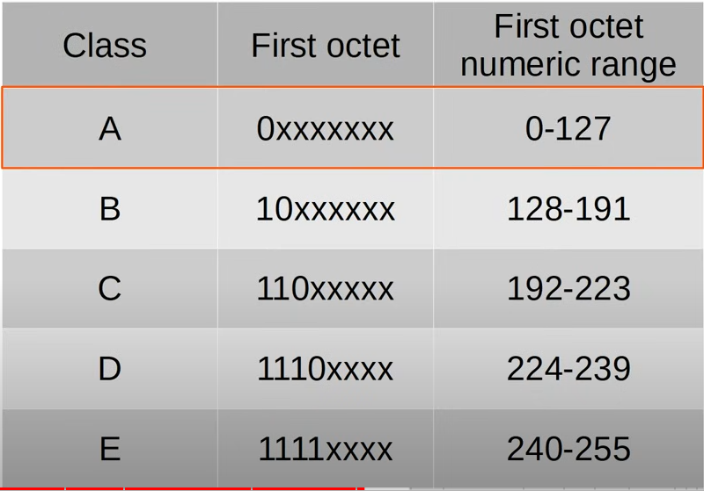

5 Classes(x means any number).
Numeric range is the range of decimal value of the first octet.
Note:Addresses in class D are reserved for multicast addresses.Multicast is another type of addresses separate from unicast and broadcast addresses.Class E addresses are reserved for experimental uses.
Note: Class A range is usually considered to be from 0 to 126.The 127 is reserved for Loopback addresses.
Loopback addresses
·Addresses range from 127.0.0.0 to 127.255.255.255.
·Used to test the ‘network stack’ (think OSI,TCP/IP model) on the local device.If a device sends any network traffic to an address in this range,it is simply processed back up the TCP/IP stack as if it were traffic received from another device.
Note:We don’t learn about IPv4 last 2 classes.
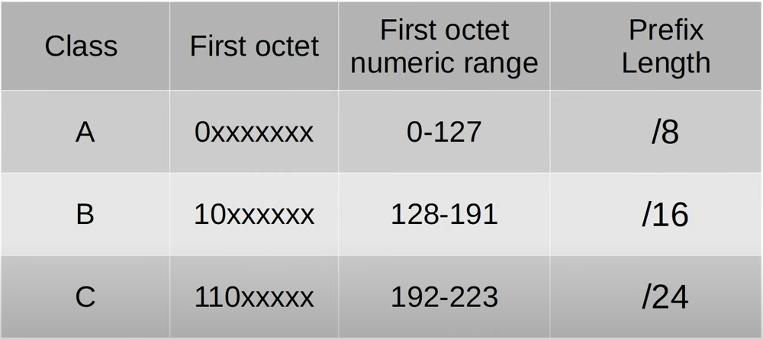

A,B,C IPv4 classes

Prefix length is used to identify network portion length of the network address.

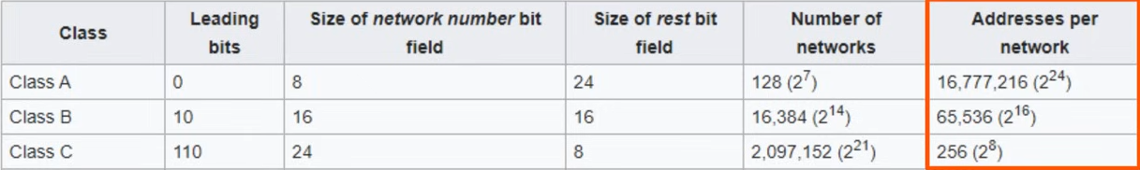
Note:Because the first address in each network is the network address,it cant be assigned to hosts.Also the last address of the network is the broadcast address,Layer 3 used when you want to send traffic to all hosts,and it also cant be assigned to hosts.So the host count is two less.
Note: Because the first address in each network is the network address,it can’t be assigned to hosts.Also the last address in network is broadcast address,the Layer 3 address used when you want to send traffic to all hosts,and it can’t be assigned to hosts.So the hosts count is two less.
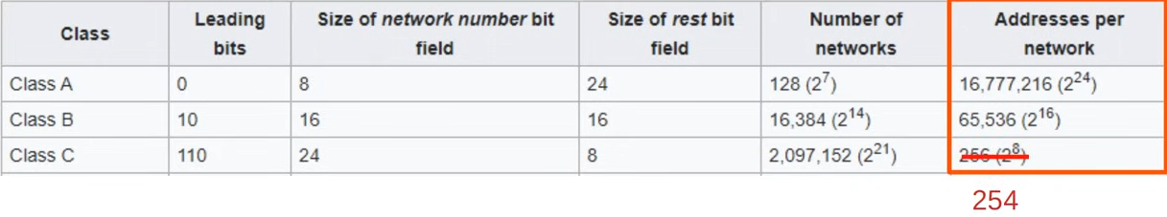
Note:There is another way of writing prefix length.That way is using dotted decimal netmask. A netmask is written in dotted decimal like an IP address,where the network portion is all 1s and host portion is all 0s.For example the netmask(network mask) of class A is 255.0.0.0,thats the dotted decimal version of 8 bits of 1s and 24 bits of 0s.
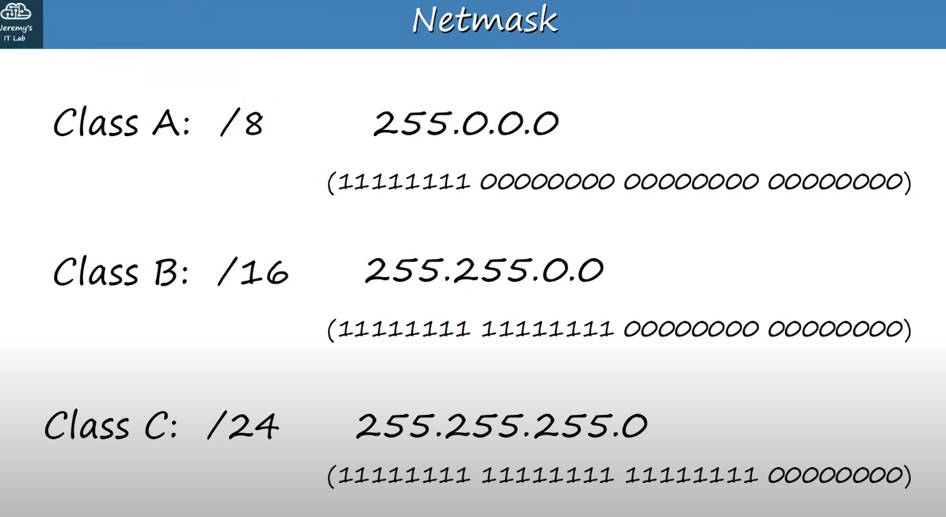

Netmasks of Class A,B,C(Netmasks are just another way of writing prefix lengths)

Network address:If the host portion of IP address is all 0s it means it is the network address.The identifier of the network itself.The network address cannot be assigned to the host.It is the first address of the network.But first usable address is one above the network address.
Broadcast address: The last address in a network is broadcast address with host portion of all 1’s.The broadcast address cannot be assigned to the host.Although it is the last address.The last usable address in the network is one under the broadcast address.The broadcast address is the last address used to send a packet to all host on the local network.If a packet is sent with this destination IP address then it’s frame in which the packet is encapsulated, has destination MAC address of all F’s,the broadcast MAC address.If PC1 sent a ping of 192.168.1.255,it would be received by PC2 and G0/0 interface of R1.
